# Command Line and Unix Introduction

Programming requires a number of tools and knowledge that aren’t obvious when you start learning a language like Python. All the online books won’t help you if you don’t get your environment set up and well understood in the long term.

To write and run programs on your machine (not in a Jupyter notebook) you will need a “plain text” editor. This means a tool for text that does not do formatting like Word does.

* On Windows, you can use Notepad or Notepad++. You might eventually want a real programming tool but Notepad++ will get you pretty far.
* On Mac, you should download Sublime Text 2 or 3 (you can use the trial) or Atom.

**Terminal Windows/Shell CMD Window**

You need to know your way around your file system and the terminal window because these will come up pretty quickly. Understanding the file system is #1 priority, because you can’t do anything in code (including web html/css) without being able to understand file paths.

Open a Terminal window on Mac. In Launchpad, search for “Terminal.”

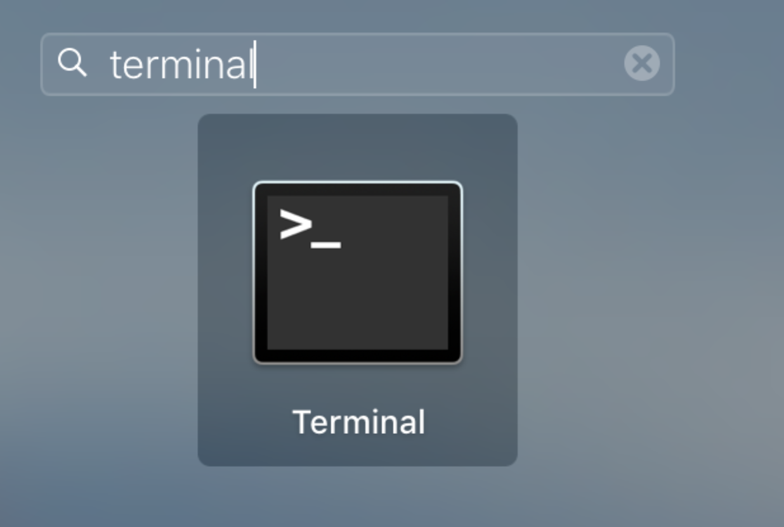

When it opens, it looks like this:

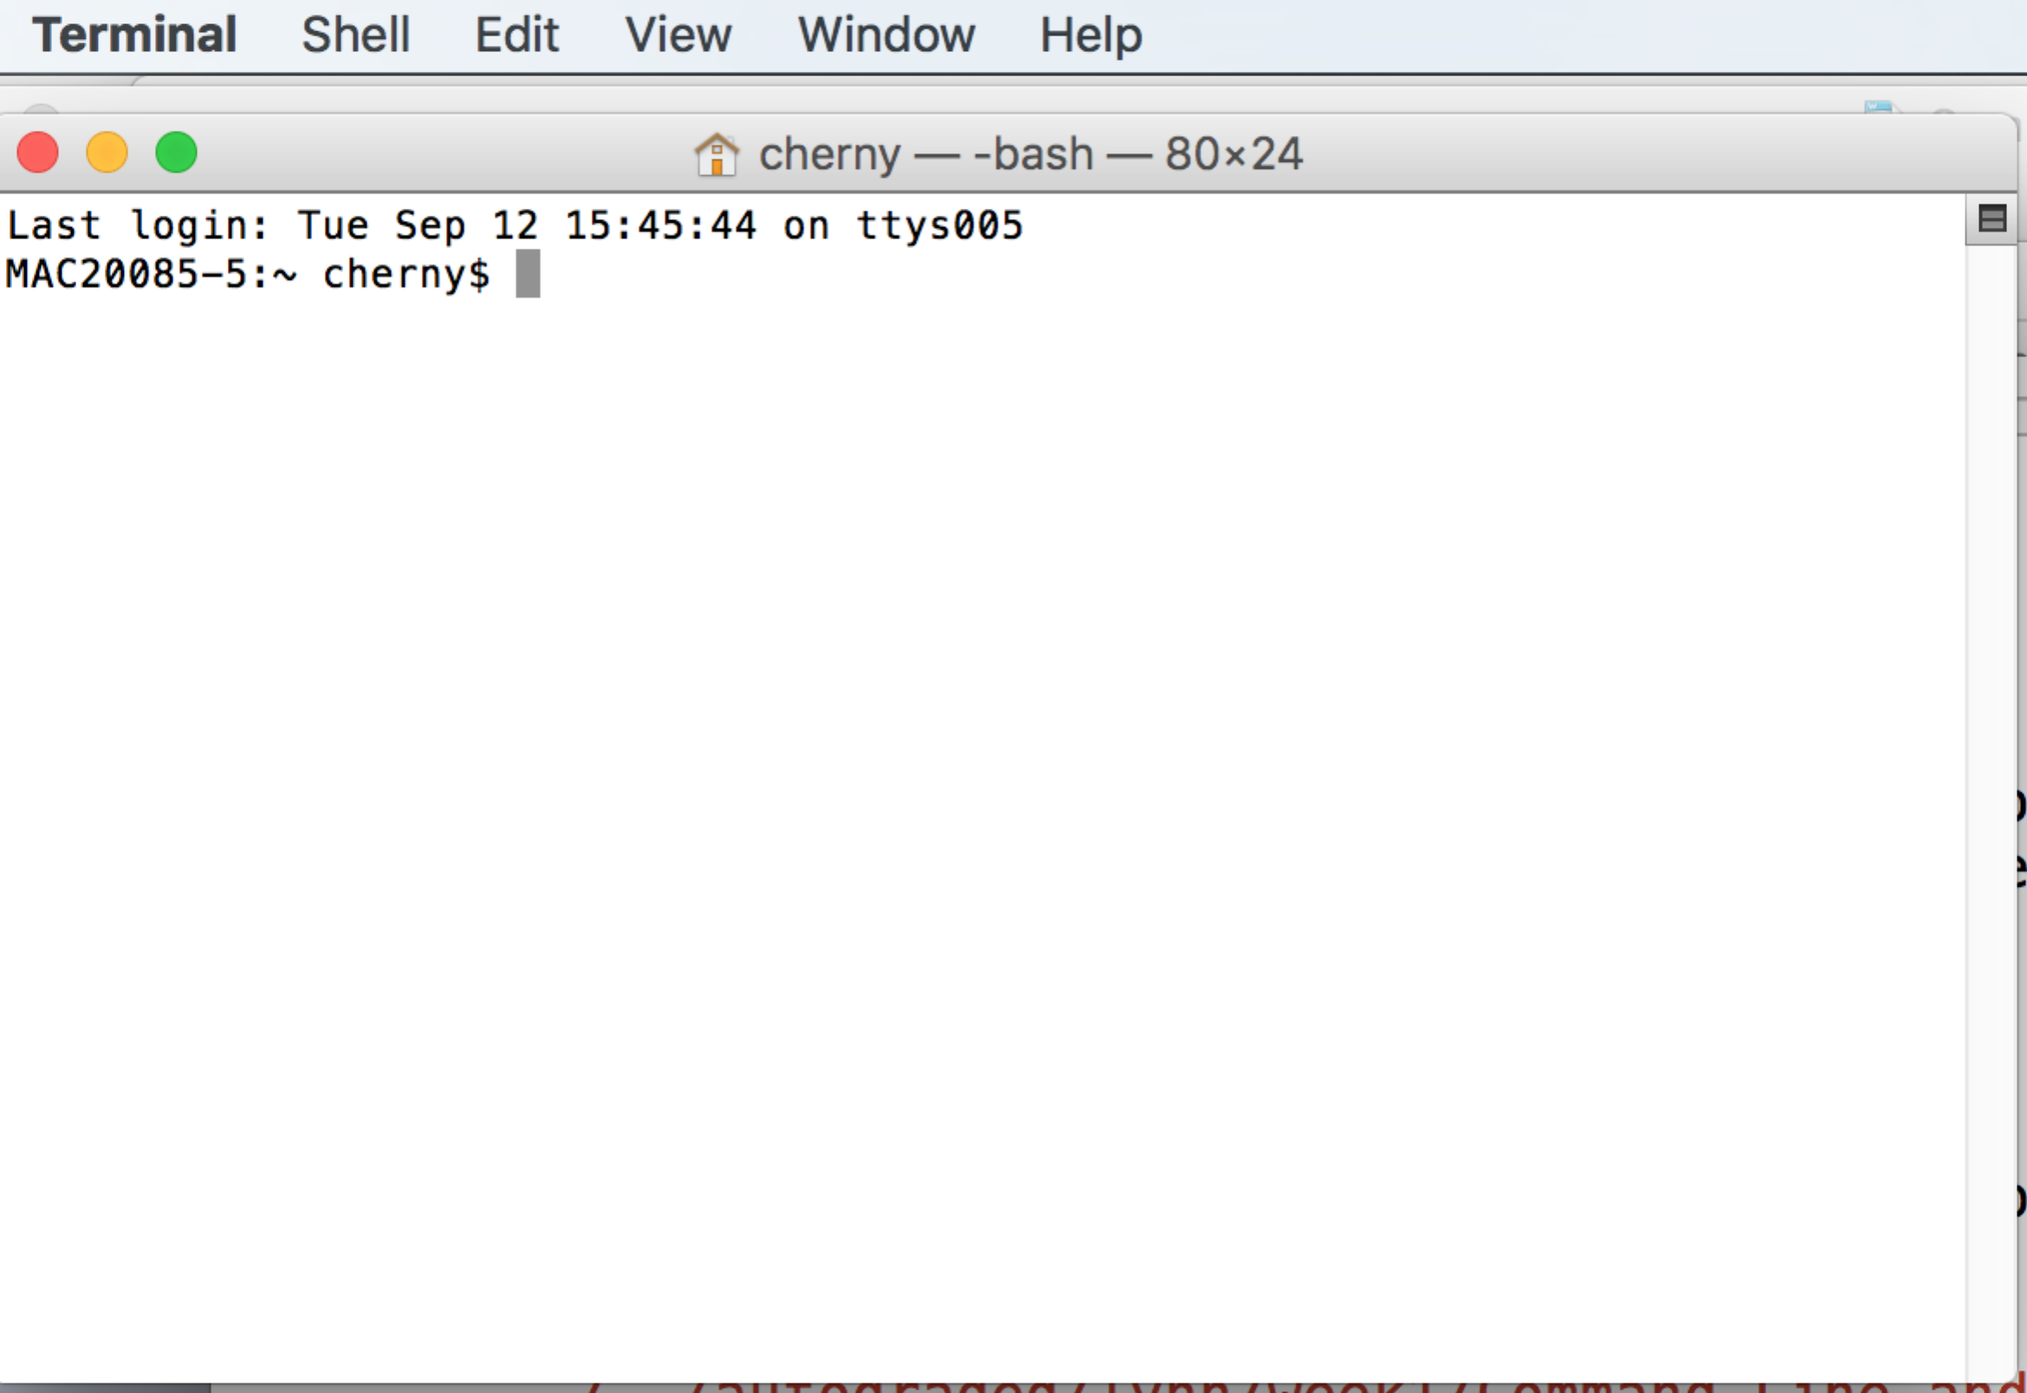

Try typing “ls” and then “return” and see what you get. You’re on your way.

On Windows, install the linux bash shell if on Windows 10 (e.g., <https://www.howtogeek.com/249966/how-to-install-and-use-the-linux-bash-shell-on-windows-10/>) or win-bash (<http://win-bash.sourceforge.net/>) or Cygwin (last resort, much larger to install).

This window is different than the CMD window on windows, because it has a smarter command system that understand some Unix. Try typing “ls” here too.

**In Class Crash Course:**

Software Carpentry lessons – DO THE FIRST FOUR (including Pipes and Filters).

<https://swcarpentry.github.io/shell-novice/01-intro/>

Extra documents that might help:

Bash guide: <https://github.com/Idnan/bash-guide>

Linux Terminal Introduction:

<https://www.howtogeek.com/140679/beginner-geek-how-to-start-using-the-linux-terminal/>

Bash shell on Windows – install and use:

<https://www.howtogeek.com/249966/how-to-install-and-use-the-linux-bash-shell-on-windows-10/>

Info on File commands in Unix (you can ignore chmod and ln):

<https://www.howtogeek.com/107808/how-to-manage-files-from-the-linux-terminal-11-commands-you-need-to-know/>